Cole (Set 2 No 8)  3 miles (5 km), 110 m of ascent, 70 to 90 minutes, easy apart from one short section | 
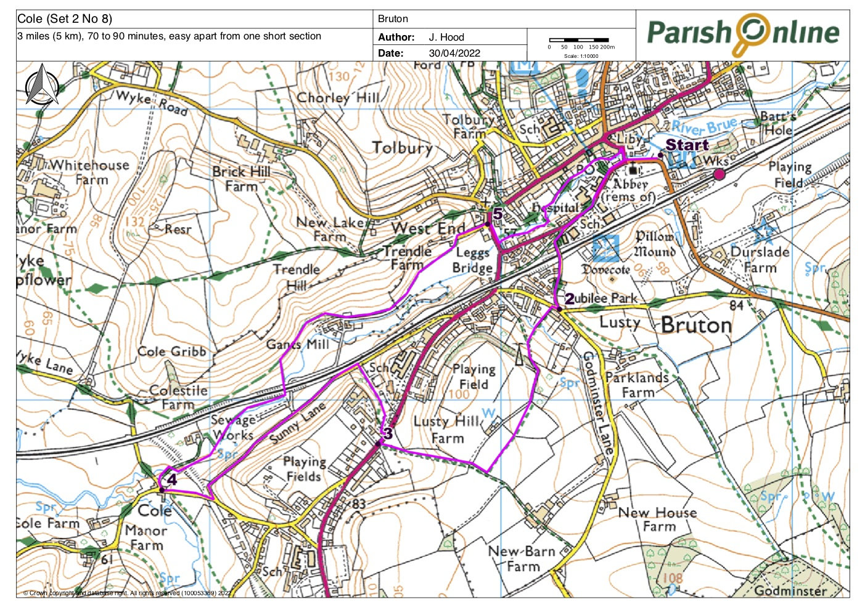

Start at Station Road car park
Turn right on leaving the car park, passing the church on your left. Go straight ahead up Silver Street, pass the buildings of King’s School, and turn first left along Godminster Lane. Cross the railway line, pass the park on your left and reach a minor cross-roads.

2
Turn sharp right, then very shortly left onto a very narrow footpath (sometimes overgrown) beside a garden fence, signed New Barn Farm. Go straight ahead over a bridge, uphill to a wooden kissing gate, across a small field to a stile into a lane. Turn left uphill and continue to a kissing gate on the left. Go into the field and head right on an indistinct footpath (the fingerpost points in the wrong direction, too far to the left). Follow the path into and through the next field to a kissing gate. Turn right and follow the farm track through a gate and downhill to the main road.

3
Cross the road turning right, then immediately left into Sexey’s School car park. At the bottom of the car park go down the grass slope aiming to and then passing to the left of the tennis courts, to reach a stile into the lane. Turn left along Gants Mill Lane and continue to a road junction. Turn right and walk into Cole.

4
Take the right turn between two houses then then immediately right into the private lane leading to Colestile (also known as Cole Style). The lane crosses the Brue by a narrow bridge. The landowners have established a permissive path through the field in front of Colestile which is more direct, easier to follow and altogether better than the ‘official’ route. Follow it if open, by turning right through the gate immediately after the bridge. Continue through the field with the River Brue to your right. [If the permissive route is closed walk up the drive to the house and take the stile into the field on your right]. The field narrows as the river and railway line gradually converge. Go under the railway.
Go through the gate and straight on up the hill ahead past a fine oak tree. The bridleway becomes indistinct. Scramble straight ahead up the steep muddy bank then turn right to go through a gate. The bridleway continues high above the River Brue then drops very steeply down towards Gants Mill. This section can be slippy in the wet, with a significant drop to the right, so take great care here. Go through a gate and follow the bridleway through a second gate, a small wood, and a further gate into the grounds of Mill on the Brue Outdoor Activity Centre. Pass beneath the house, turn left up to a gate then right down the drive to reach the main road at West End.

5
Cross the road at the zebra crossing and turn right, then left after crossing the river through a gap in the wall to follow Riverside Walk past houses, left to cross the river again then right along Lower Backway. Continue along the Riverside Walk, turning right at the end to cross Church Bridge. Go left at the church to return to the car park.

